1. What is Excel? Why do we use Excel?

Ans: Excel is a spreadsheet program from Microsoft and a component of its Office product group for business applications. Microsoft Excel enables users to format, organize and calculate data in a spreadsheet.

By organizing data using software like Excel, data analysts and other users can make information easier to view as data is added or changed. Excel contains a large number of boxes called cells that are ordered in rows and columns.

2. List all the versions of Microsoft excel. Compare excel software provided from multiple vendors.

Ans:

Excel 365

Excel 2021

Excel 2019

Excel 2016 and 365

Excel 2013 (Windows)

Excel 2011 (Mac)

Excel 2010 (Windows)

Excel 2008 (Mac)

Excel 2007 (Windows)

Excel 2004 (Mac)

Excel 2003 (Windows)

Older Windows versions (2002, 2000, 97, 95, 4.0, 3.0, 2.0)

Older Mac versions (2001, 2000, 98, 5, 4, 3, 2, 1)

OS/2 Versions (2.2, 2.3, 3)

Vendor Comparison Templates in Excel are as follows:

1. income cost comparison form

2. wadget budget execution comparison form.

3. supplier comparison table.

4. sampler price-comparison purchase chart.

5. template income statement.

6. income statement vertical analysis template.

7. year-end inventory analysis.

8. conference minutes template.

9. sales performance analysis comparison form.

10. sales volume comparison chart.

3. How to create bar charts in excel, demonstrated with practical examples.

Ans:

**Step 1:** Enter your data into Excel columns.

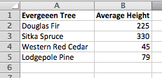

**Step 2:** Click and drag your mouse across the data that will appear in the chart.

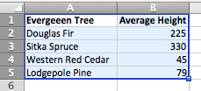

Confirm the highlighted columns contain one independent variable and one dependent variable, and the column headers if desired (Excel will make one of the headers as the chart title).

**Step 3:** From the ribbon, click *Chart*, click the *Bar* icon, and then click *2-D Clustered Bar* (with a single dependent variable as we are using here, the results will be the same no matter which option you choose).

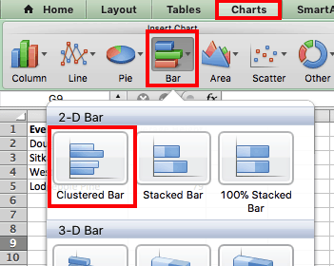

**4. Create an analytics dashboard in python and present your findings**

**Answer:**

**5. How to connect Excel with the databases**

**Answer:**

**Connect Excel and load data**

1. To connect Excel to a database in SQL Database, open Excel and then create a new workbook or open an existing Excel workbook.
2. In the menu bar at the top of the page, select the **Data** tab, select **Get Data**, select From Azure, and then select **From Azure SQL Database**.

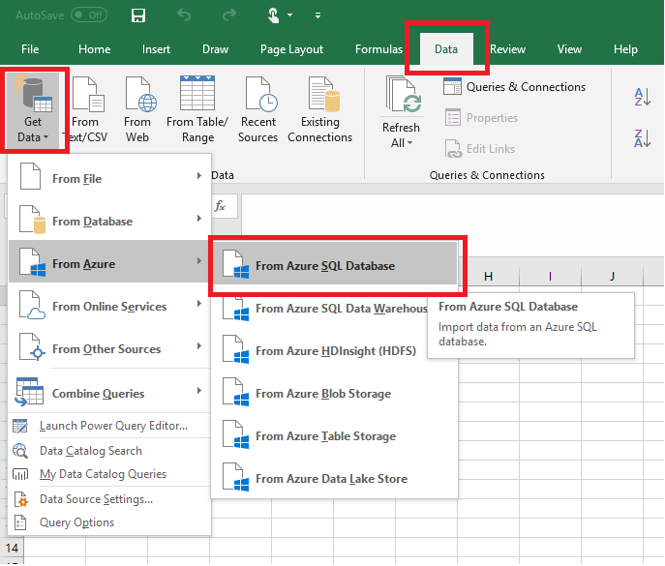

1. In the **SQL Server database** dialog box, type the **Server name** you want to connect to in the form <*servername*>**.database.windows.net**. For example, **msftestserver.database.windows.net**. Optionally, enter in the name of your database. Select **OK** to open the credentials window.

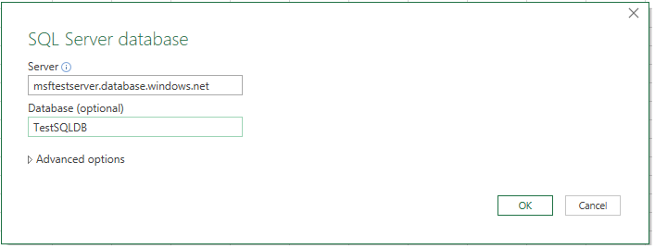

1. In the **SQL Server database** dialog box, select **Database** on the left side, and then enter in your **User Name** and **Password** for the server you want to connect to. Select **Connect** to open the **Navigator**.

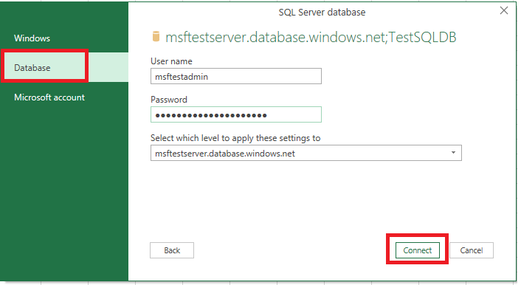

1. In the **Navigator**, select the database you want to work with from the list, select the tables or views you want to work with (we chose **vGetAllCategories**), and then select **Load** to move the data from your database to your Excel spreadsheet.

